# Managing videos for My Learning Campus (MLC) with Brightcove

## General idea

MLC will be using videos in the cinema section. Those videos will be managing by the Brightcove system. Videos will be uploaded to Brightcove and metadata added to ensure they get added to ‘Smart Playlists’. Those playlists of videos will then be available to users via the MLC pages.

A Glossary is provided at the end of this document explaining terms used in the Brightcove system.

## Basic workflow

1. Create or acquire a suitable training or information video, with suitable distribution rights. Use highest quality video you can. Brightcove will transcode to other versions suitable automatically.
2. Upload video to Brightcove system using Brightcove Studio.
3. Add metadata to video within Brightcove Studio – in particular:
   1. ‘tags’ to enable video to become part of one or more Smart Playlists. These are free text so make sure you spell your tags correctly.
   2. Descriptive Video name.
   3. Short description of video contents.
   4. Add a further information URL (such as a web page URL or page on z-net).
   5. Choose frame in video as a suitable picture to be loaded in the Brightcove Player.
4. Check your video appears in the Playlist(s) you were expecting.
5. If the Playlist(s) were already existing ones used by MLC then you are all finished.
6. If you need a new Smart Playlist then:
   1. Create a new Smart Playlist with a suitable name and tag name.
   2. You may need to revisit videos that should be part of this new Playlist to add the tag required, so that the video appears in the Playlist.

Details on these steps are below.

## Displaying a Playlist from MLC

MLC uses URL’s linked from tiles. A page (cinemaFlexi) has been created with will take arguments as follows:

https://collaboration.zurich.com/community/00900/SitePages/cinemaFlexi.aspx?bclid=3905492255001&bctid=4006608774001

This URL loads playlist (bclid) 3905492255001 and starts with video (bctid) 4006608774001

Video (bctid) is optional – if none is specified then the first video in the Playlist is automatically used, so a URL in this case would be:

<https://collaboration.zurich.com/community/00900/SitePages/cinemaFlexi.aspx?bclid=3905492255001>

The same page is used for all Playlists.

## Detailed Actions

### Warning

At the time of writing, Brightcove are soon to roll out a new HTML5 version of the Brightcove Studio and Player system. Zurich are currently using the existing Flash based system, and using the Smart Player. Brightcove documentation may refer to both of these systems, which may be confusing. Please refer to screen shots below to help identify the appropriate documentation, as the 2 systems look very different.

### Uploading a video(s) to Brightcove

1. Logon to Brightcove Studio:
   1. Browse to ‘brightcove.com’
   2. Use dropdown (‘Customer Sign in’) on home page and choose ‘Video Cloud’.

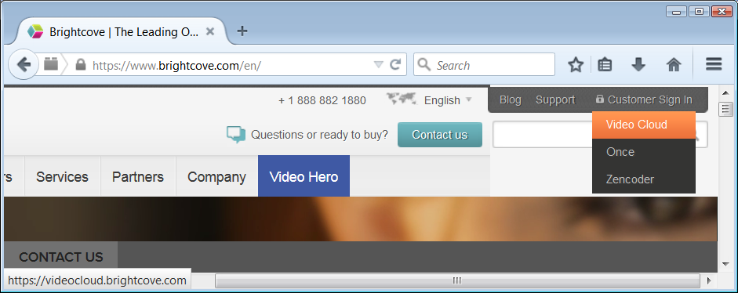

* 1. Logon using your Brightcove ID. 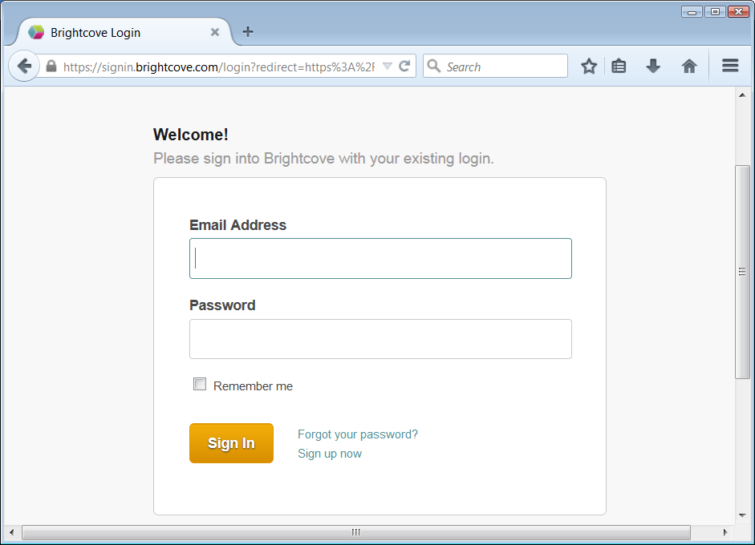

1. You should arrive at Brightcove Studio. Make sure you are using the ‘Learning Campus’ account (check top left corner dropdown in Brightcove Studio’) 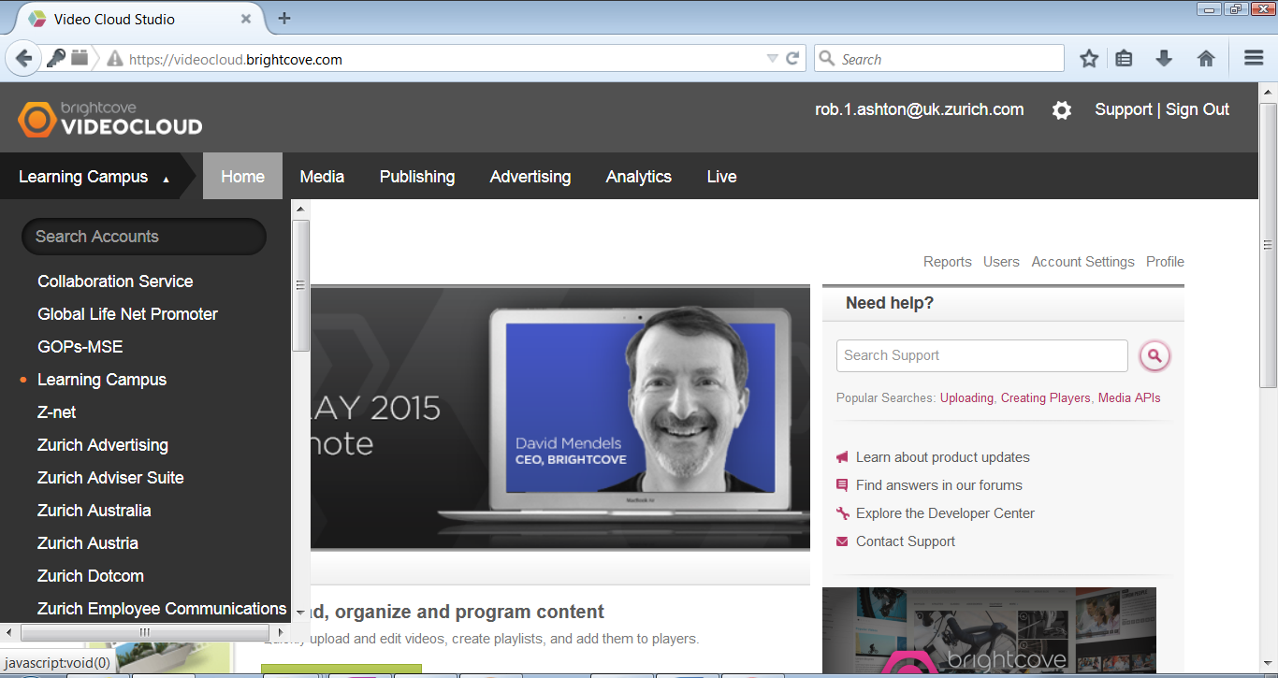
2. Click on ‘Media’ on Brightcove Studio main menu bar. This will list all the current videos. At the bottom left you will see a green up arrow – click that and choose ‘standard upload’ 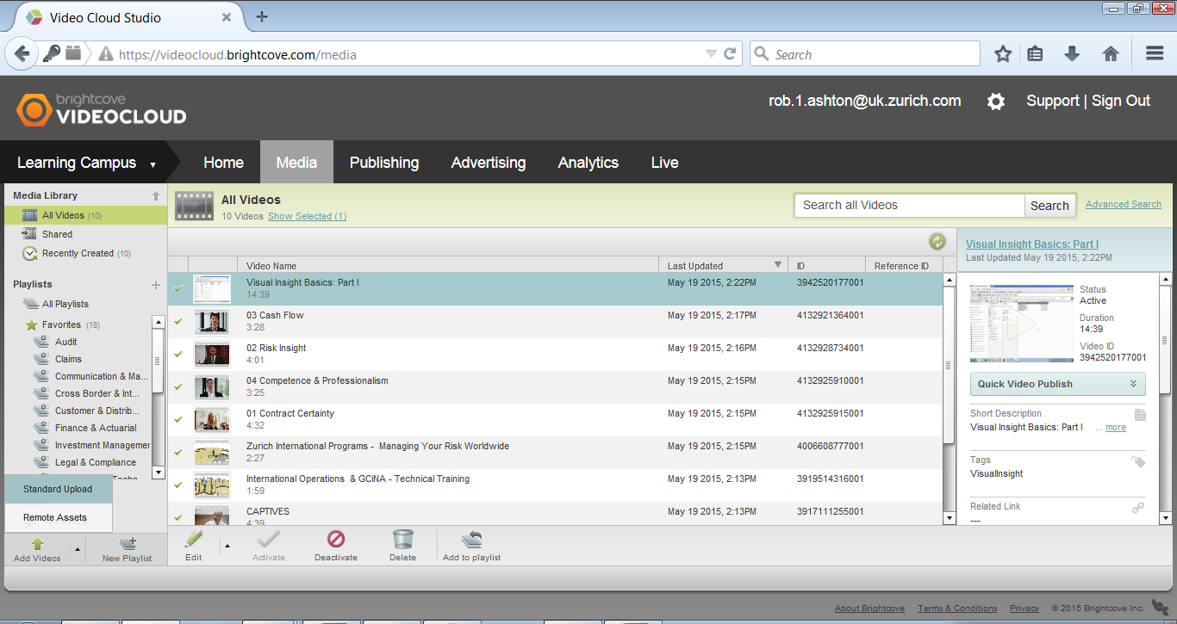
3. You will be presented with a standard windows file choosing dialog. Find you video(s) and add to the Brightcove Studio list that has appeared. You can as many videos as you want to the list, and you can add tags to many videos at once at this stage if you want. Don’t worry if you don’t add the tags here, you can add later as well. 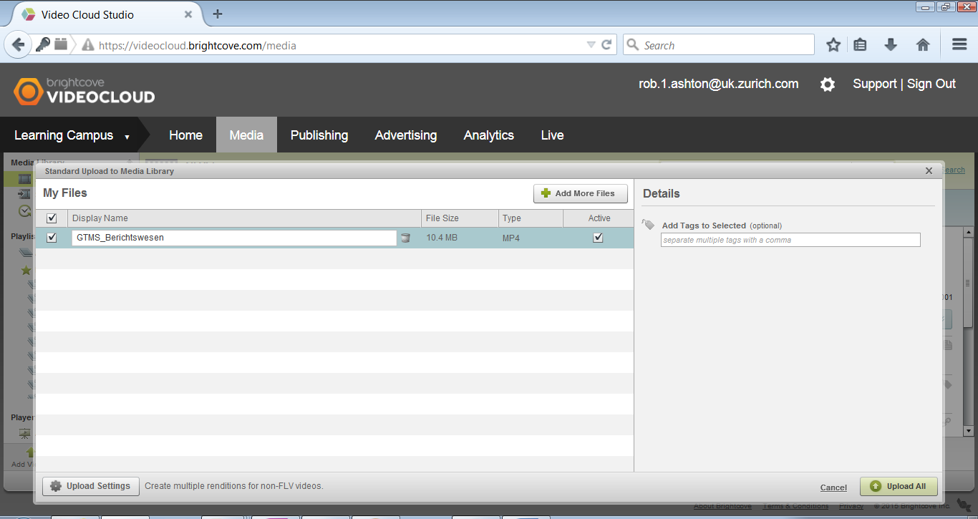
4. When have added everything, click green button ‘Upload All’ at bottom right. Files will upload. This may or may not take a long time depending on your network speed.
5. When uploading has finished, your videos will appear in the Brightcove Studio list.

Brightcove have a video and information that shows these steps here:

<http://support.brightcove.com/en/video-cloud/docs/uploading-videos-media-module>

NOTE – do not fiddle with the rendition settings!

### Adding metadata to videos

1. Once your videos are uploaded, or to edit metadata of any existing video, use the Brightcove Media module in Brightcove Studio via the ‘Edit’ icon below the video list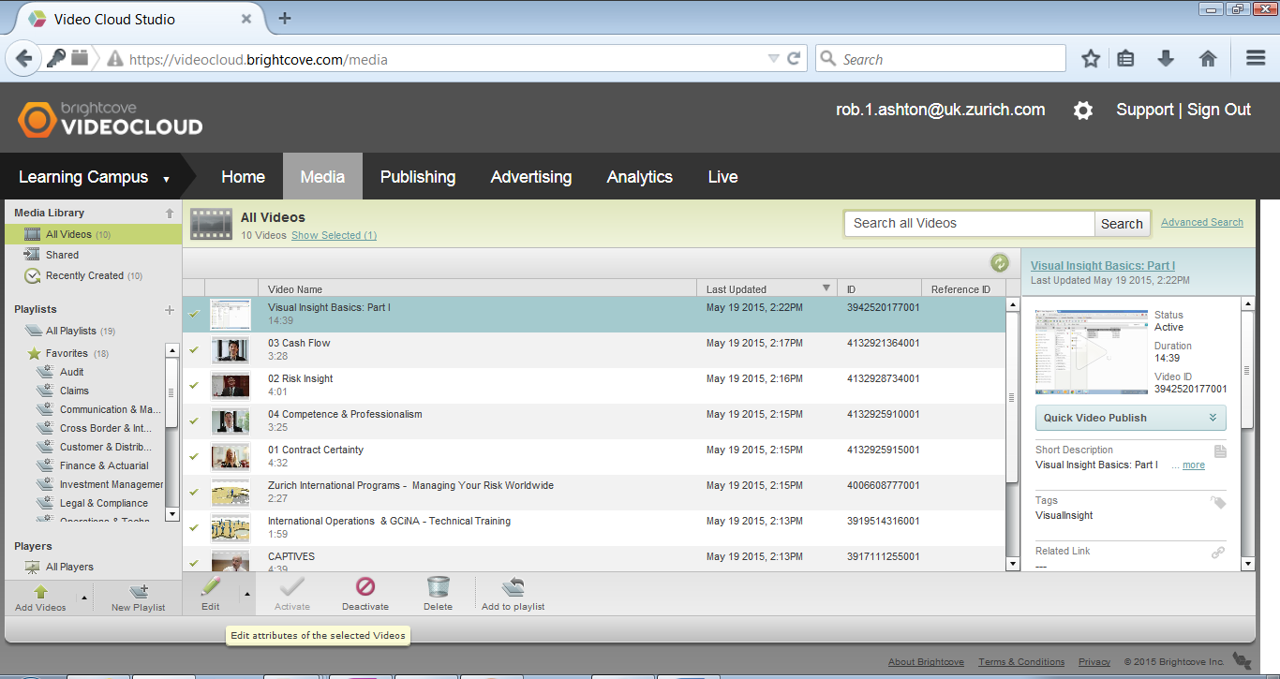
2. The tabbed dialog allows you to enter and edit all aspects of a videos metadata, but we only need the ‘Basic’ tab 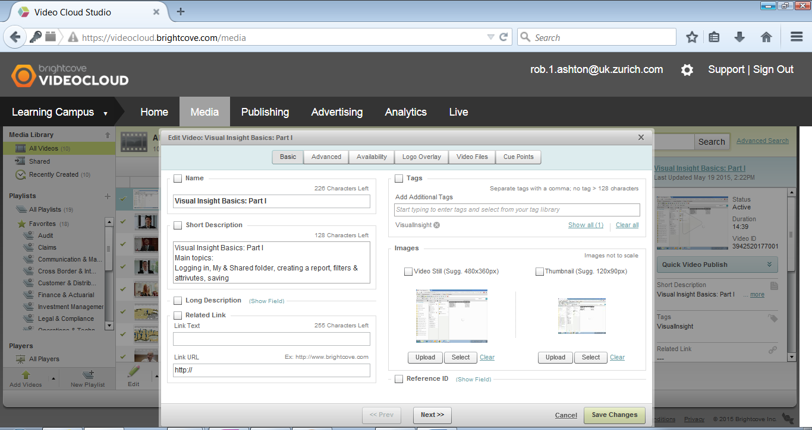
3. Fill in as much as possible on the Basic tab. Particularly important are the ‘tag’ section (otherwise your video will not appear on a Playlist and no one will find it), the ‘images’ section (so that an image appears in the Playlist and Player) and the ‘name’ & ‘short description’ (so that the user has a good idea what the video contains).

### Managing Smart Playlists

Playlists are managed in the Brightcove Media Module. There are 2 kinds:

1. ‘Manual Playlists’ must have videos added to them manually, via a ‘select your videos’ type dialog.
2. ‘Smart Playlists’ use tags to select which videos appear in them. So once a playlist has been created, videos can be added by just using that playlists’ tag in your video metadata.

For MLC we are using Smart Playlists (though nothing needs to change anywhere if you would rather use a manual playlist).

### General process for creating a Smart Playlist

1. Create a new Smart Playlist: 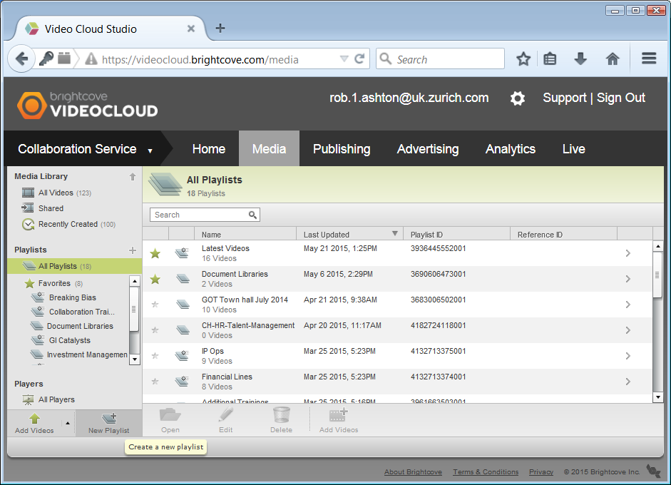
2. Fill in the dialog: 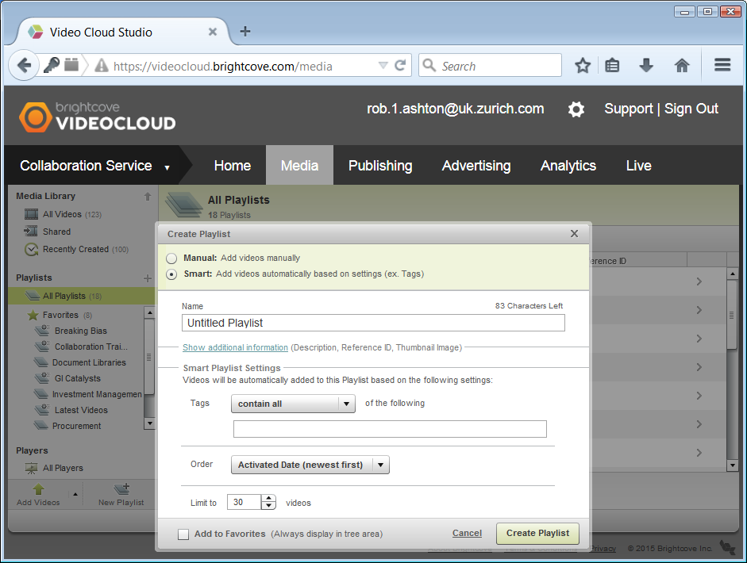
3. Note the 2 drop down boxes – think carefully about what you need (you can change the settings afterwards by editing the playlist).

### Adding a video to a Smart Playlist

All you need to know is what tag needs to be applied to the video. If you don’t know, just take a look at the playlist properties.

Video tags are entered here: 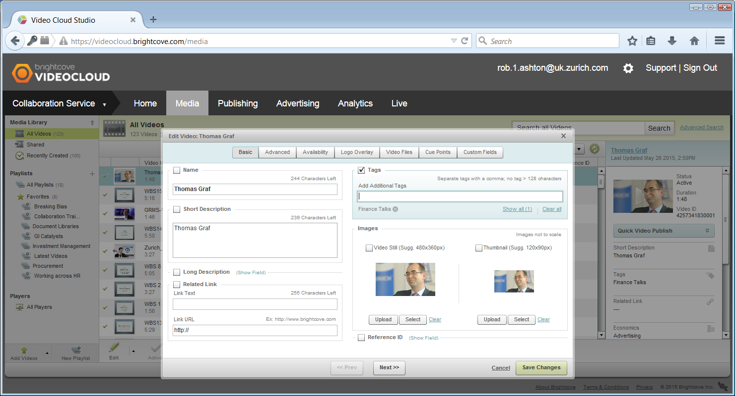

### Getting the required references to Playlists and Videos in Brightcove Studio

In order to create a URL that will load our video playlist into the player (and optionally load a particular video when the player appears on the page) we need the reference to the playlist and a video. These are best copied from the following locations:

#### Get a playlist id:

1. Select ‘All Playlists’ in left hand nav in Brightcove Studio.
2. Locate the playlist you need in the main list. You will see the playlist id in that list, but that one is not copyable.
3. Double click the playlist. This opens a list of videos that belong to this playlist.
4. …and it also allow us to copy the playlist id from just under the playlist title: 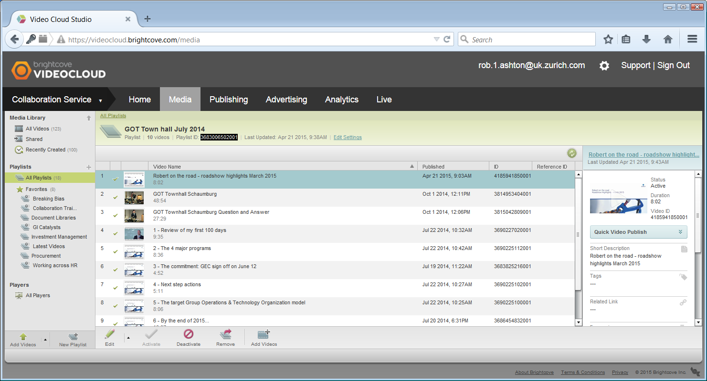
5. Handily, if you select the video you want to load at start (if you want a particular video) you can copy the video id by selecting the video in the main list, and then selecting and copying the id from the video info on the right: 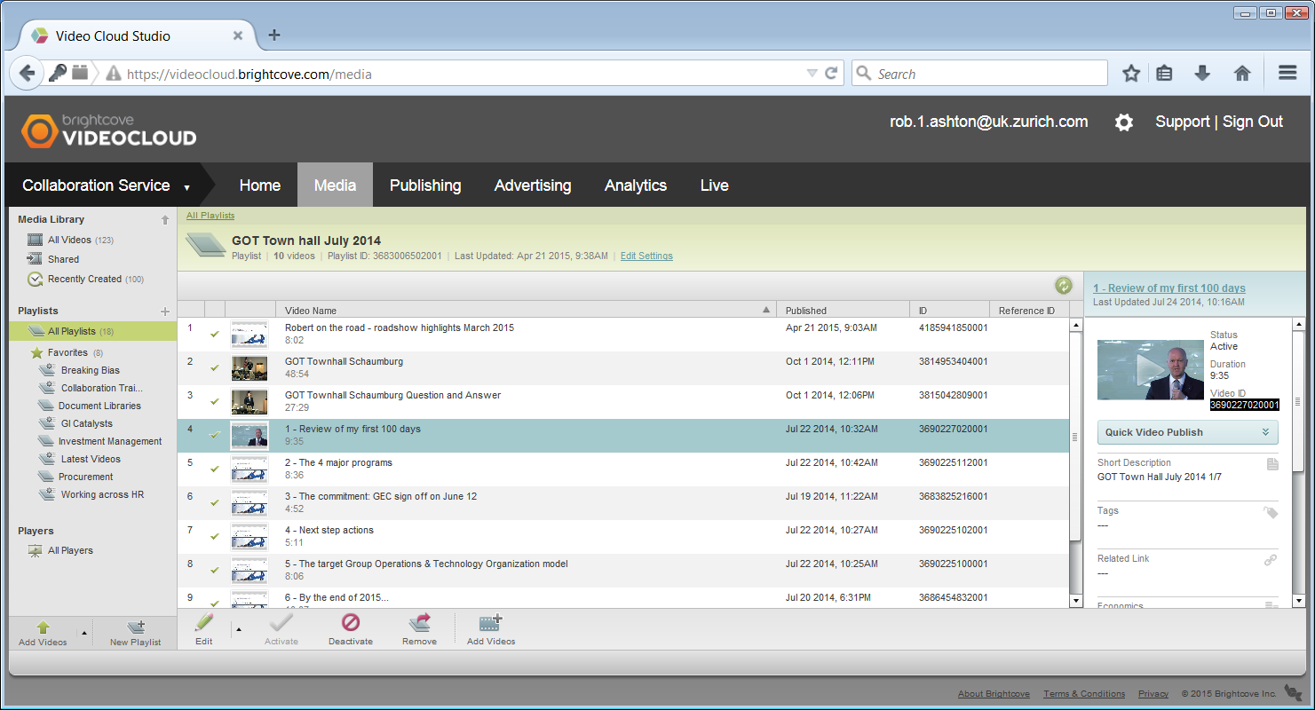

### Putting it all together

Now that we have a playlist id and (optionally) a video id we can create our URL for use in links like this:

<https://collaboration.zurich.com/community/00900/SitePages/cinemaFlexi.aspx?bclid=3905492255001&bctid=4006608774001>

This URL loads playlist (bclid) 3905492255001 and starts video (bctid) 4006608774001 (video (bctid) is optional).

The <https://collaboration.zurich.com/community/00900/SitePages/cinemaFlexi.aspx>? Part is always the same. The Playlist part (bclid=xxxxxxxxxxxxx) is required.